No. 01-08
March 26, 2002

RULE AMENDMENT

On December 1, 2001, National Instrument 21-101 – Marketplace Operation (the “Marketplace Operation Instrument”) and National Instrument 23-101 – Trading Rules (the “CSA Trading Rules”) became effective. These National Instruments are part of the initiative by the Canadian Securities Administrators (the “CSA”) to create a framework for the competitive operation of traditional exchanges, quotation and trade reporting systems (“QTRSs”) and Alternative Trading Systems (“ATSs”).

Members are advised effective April 1, 2002, CDNX will adopt the Universal Market Integrity Rules (“UMIR”) as the rules governing the trading conduct of its Members and Participating Organizations. As an exchange, CDNX may either monitor or enforce these requirements in relation to its Members and Participating Organizations directly or through a regulation service providers. CDNX retained Market Regulation Services Inc. (“RS”) to be its regulation service provider effective March 1, 2002.

RS was established in 2001 as a joint initiative of The Toronto Stock Exchange and the Investment Dealers Association of Canada to provide an independent securities trading regulatory body. RS has been recognized by the Alberta Securities Commission, British Columbia Securities Commission, Manitoba Securities Commission, Ontario Securities Commission and the Commission de valeurs mobilières du Québec (the “Recognizing Regulators”), and as such, is authorized to be a regulation services provider for the purposes of the Marketplace Operation Instrument and the CSA Trading Rules.

As a regulation services provider, RS will administer and enforce trading rules for the marketplaces that retain the services of RS. Following approval by the Recognizing Regulators, RS has adopted UMIR as the integrity trading rules that will apply in any marketplace that retains RS as it regulation services provider. Appendix “A” is a chart outlining a summary of the obligations under UMIR that will be imposed on marketplaces and on persons who may obtain access to a marketplace. The text of UMIR is contained in Appendix “B” and the text of the Policies adopted under UMIR is set out in Appendix “C”.
Effective April 1, 2002, UMIR will apply to trading on CDNX and govern the trading conduct of its Members and Participating Organizations. Implementation of certain provisions of UMIR will be deferred to permit required systems development and changes by the exchange, information processors, data vendors and dealers. Implementation of the following provisions of UMIR will be deferred until June 3, 2002 or such later date as may be published by RS:
1. the requirement under Rule 6.2 that an order entered on a marketplace contain a designation if the order is entered for the account of a person who is an insider or a significant shareholder of the issuer of the security which is the subject of the order; and
2. the requirement under Rule 9.1 that order entry for a particular security be inhibited during a regulatory halt or suspension affecting that security.
Any disciplinary proceedings relating to conduct that occurred prior to the date on which UMIR becomes effective, as agreed upon by RS and CDNX, that are or were initiated:
- prior to that date shall be continued by CDNX and administered by RS in accordance with Exchange Requirements in effect and applicable to such disciplinary proceedings prior to that date; and
- on or after that date in respect of the breach or failure to comply with any Exchange Requirement in respect of which RS provides Services shall be undertaken by RS in accordance with the applicable procedural provisions of UMIR and shall be subject to the imposition of any sanction or remedy under UMIR as if the breach or failure to comply had been a breach or failure to comply with an Exchange Requirement contained in UMIR.
Upon the adoption of UMIR as the integrity trading rules for CDNX, the existing rules and policies of CDNX will be amended to delete or vary any provisions where the subject matter is covered by UMIR. CDNX’s amended “C”, “D” and “F” Rules and CDNX Trading Policies are attached hereto as Appendix “D”. A summary of the amendments is contained in Appendix “E”.
CDNX will retain its rules and policies that are specific to its market, including provisions related to systems operation, market quality and market structure. These market specific rules and policies may also be amended in response to matters contained in the Marketplace Operation Instrument and the CSA Trading Rules. Any additional changes to the rules and policies of CDNX will be the subject of notices published by CDNX.

CANADIAN VENTURE EXCHANGE INC.

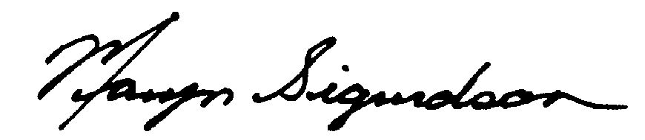

Maryn L. Sigurdson
Vice President, Corporate Disclosure and Compliance

